**­**

**For Immediate Release**

**Media Contact:**

Sharmon Rodgers

Delano Associates [sharmon@delanoassociates.com](mailto:sharmon@delanoassociates.com)

949.289.0674

**Celerity Expands 18G Fiber Optic HDMI Solutions**

*Company will demonstrate new fiber optic cables, wall plates and switching solutions. Partnering with AVProStore at CEDIA to show cable performance with Murideo Signal Generator and Analyzer.*

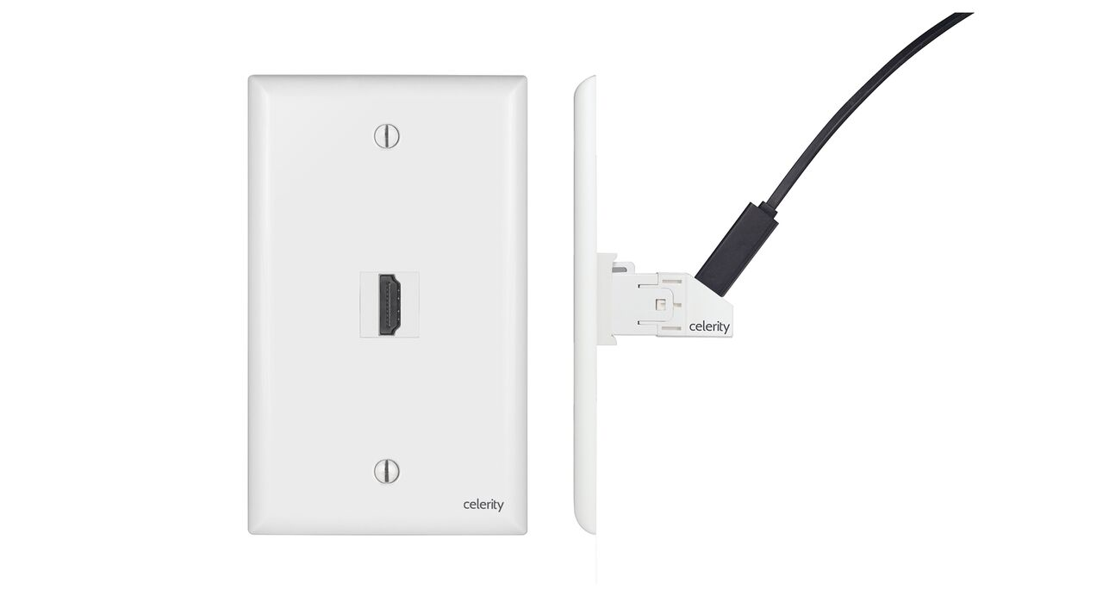**Irvine, CA – September 07, 2016** – Celerity Technologies will expand its 18Gbps fiber optic HDMI product range to include Keystone wall plates, a premium fiber optic cable with aluminum unibody connectors and the company’s first HDMI switcher.

Celerity HDMI Keystone wall plates have been designed to provide a clean in-wall connection point for long distance HDMI runs. To connect the source and display with the keystone wall plates, Celerity will offer 18Gbps 3ft and 6ft HDMI cables, including cables with an inline 5V USB cable for display side power.

The Celerity Fiber Optic (CFO) cable is designed for high-end in-room connections. The solid aluminum connector encloses the optical module and connects directly to the source and display. Power for the transmit side is supplied by HDMI internal 5V and power for the receiving side is supplied by an integrated 5V USB power cable. Celerity CFO cables will be available in 10ft and 20ft lengths.

“Our customers continue to ask for more fiber optic solutions and our Keystone and CFO cables are really useful fiber optic products. They are easy to use, no fiber terminations required and the picture quality is as good as it gets,” said Buzz Delano, Director of Business Development for Celerity.

Celerity will team up with AVProStore at CEDIA to educate about 18Gbps performance, system design and testing using the Murideo Fresco Six Signal Generator and Analyzer at the Celerity booth 2904 and AVPro, booth 7318. “It is so important to understand how to correctly design and install a true 18Gbps system and we want to educate our dealers,” 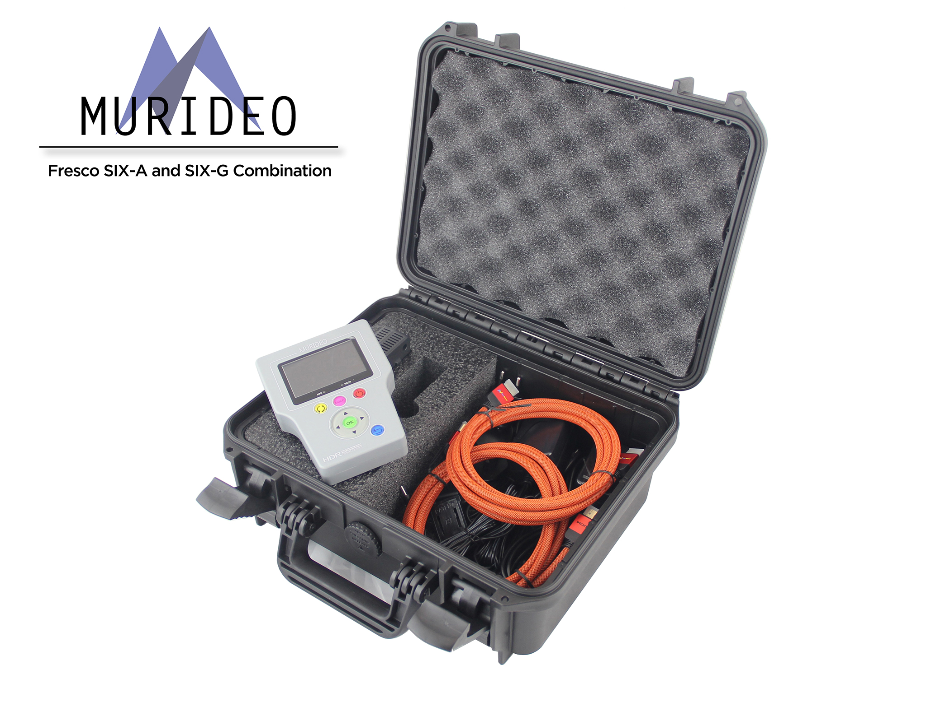 said Matt Murray, General Manager of AVProStore and Delano in a combined joint statement. “There’s a lot of myth and mystery about 4K that our industry needs to understand correctly” Murray and Delano continued.

In category expansion plans, Celerity will show dealers the company’s first HDMI 2.0 switcher supporting a Celerity fiber optic output as well as an HDMI 2.0 output. Celerity expects to deliver the switcher during the fourth quarter of 2016.

###

**About Celerity Technologies, Inc.**

Founded in 2012, Celerity Technologies, the inventor of the first fiber optic HDMI cable to support Audio Return Channel, is dedicated to providing the best quality connection between high definition audio and video components for the home and business. Celerity possesses extensive electrical and mechanical engineering experience in signal processing over fiber optics for HDMI, DisplayPort, DVI, and Ethernet. Visit [www.celeritytek.com](http://www.celeritytek.com) for more information.

*Celerity is a trademark of Celerity Technologies, Inc. HDMI, the HDMI logo and High Definition Multimedia Interface are trademarks or registered trademarks of HDMI licensing, LLC in the United States and other countries.*